4. Reproducing IRIS
We reproduced the IRIS pipeline on an HPC cluster at NDSU equipped with AMD EPYC 7532 32-core processors and 256 GB of RAM per compute node. GPU-accelerated tasks (LLM inference and fine-tuning) were executed on NVIDIA A100 GPUs allocated through a PBS job scheduler. The setup required configuring multiple interconnected components: CodeQL 2.15.3 for static taint analysis, Java 8 and Java 11 (the former for compiling benchmark projects, the latter for running CodeQL), Maven 3.6.3, and DeepSeekCoder 7B as the language model.
We chose DeepSeekCoder 7B over GPT-4 (used in the original paper) for two reasons. First, it runs locally on the cluster's A100 GPUs at zero API cost, making experiments fully reproducible without paid API access. Second, the IRIS paper itself reports that DeepSeekCoder detects 52/120 vulnerabilities — not as strong as GPT-4 but meaningful enough for reproduction and evaluation. The model (~13 GB) loads in approximately 5 seconds and processes API labeling batches at roughly 37 seconds per batch. A full IRIS pipeline run on a single project takes 10–30 minutes of GPU time depending on project size. Fine-tuning with LoRA completed in approximately 15 minutes (921 seconds for 3 epochs over 2,536 training examples). The cluster-guided prioritization step itself requires no GPU and executes in under 1 second on all projects. Total GPU time across all experiments (16 IRIS runs, fine-tuning, two evaluations) was approximately 8–10 hours.
Table 1 summarizes the software and hardware components of our reproduction environment. We list these explicitly because IRIS depends on specific version interactions between CodeQL, Java, and the LLM — mismatches cause the compatibility issues documented in Section 4.1.
Table 1: Reproduction Environment
Component | Configuration
CodeQL | 2.15.3 with bundled Java query packs (v0.8.3)
Java | OpenJDK 1.8.0_222 (compilation) + OpenJDK 11 (CodeQL runtime)
Maven | 3.6.3
LLM | DeepSeekCoder 7B Instruct (~13 GB), NVIDIA A100 GPU
Python | 3.9 with torch, transformers, accelerate, peft
Dataset | CWE-Bench-Java, 16 projects across CWE-22/79/94
Hardware | AMD EPYC 7532 32-core, 256 GB RAM, NVIDIA A100 GPU
4.1 Compatibility Fixes
The published IRIS code did not run out-of-the-box in our environment. We identified and resolved five compatibility issues, none of which were documented in the IRIS repository. We present these in detail because they represent a practical reproducibility contribution — other researchers attempting to reproduce IRIS will encounter the same problems.
Table 2 lists the five compatibility fixes required to run the published IRIS code in our environment. The 'Root Cause' column explains why the original code fails, and the 'Fix Applied' column describes our resolution.
Table 2: Compatibility Fixes Required for Reproduction
# | Issue | Root Cause | Fix Applied
1 | Pack version | Wildcard "*" in qlpack.yml pulled incompatible v9.0.2 packs | Pinned to v0.8.3, used --additional-packs flag
2 | Query API | ActiveThreatModelSource absent in CodeQL 2.15.3 | Replaced with RemoteFlowSource in 5 .qll files
3 | Version config | IRIS expected query version "1.8.1"; ours ships "0.8.3" | Updated CODEQL_QUERY_VERSION in config.py
4 | Temperature | Newer transformers library rejects temperature=0.0 | Changed to 0.01 with do_sample=True
5 | Pack resolution | CodeQL ignores --search-path for pack dependencies | Switched to --additional-packs in query runner
Each fix was straightforward once diagnosed, but the diagnostic process required familiarity with CodeQL internals, Python library versioning, and the IRIS codebase. These fixes collectively illustrate the fragility of research tool chains that span multiple software ecosystems.
4.2 Reproduction Results
We ran both CodeQL baselines and the full IRIS pipeline on 16 projects from CWE-Bench-Java. Nine additional projects failed to build due to dependency issues and were excluded.
To illustrate, the Struts vulnerability (CVE-2020-17530) involves attacker-controlled HTTP input reaching OGNL expression evaluation:
String input = request.getParameter("query"); // SOURCE
Object result = Ognl.getValue(input, context); // SINK
CodeQL does not recognize Ognl.getValue() as a sink in its default specifications, so this entire vulnerability class is invisible without LLM-inferred specifications. In practice, the taint path passes through multiple interceptors and parameter maps, producing the high path counts shown below.
Table 3: CWE-94 Results (Code Injection) — CodeQL found 0 alerts on all projects
Project | IRIS Paths | TP Paths | Precision | Sources Labeled | Sinks Labeled
Struts 2.5.25 | 5,546 | 101 | 1.8% | 359 | 533
Spring Cloud GW 3.0.6 | 310 | 27 | 8.7% | 147 | 180
Commons-text 1.9 | 201 | 120 | 59.7% | 42 | 66
ff4j 1.8.13 | 1,083 | 163 | 15.1% | 23 | 53
Cron-utils 9.1.5 | 18 | 9 | 50.0% | 23 | 53
Rocketmq 4.9.6 | 1,272 | 1 | 0.08% | — | —
IRIS detected all 6 CWE-94 vulnerabilities where CodeQL found zero alerts. This confirms the original paper's core finding: LLM-inferred specifications enable detection of code injection vulnerabilities that CodeQL's built-in rules miss entirely. The precision varies dramatically — from 59.7% (Commons-text) to 0.08% (Rocketmq) — foreshadowing the need for path prioritization.
CWE-79 vulnerabilities involve user input reflected in HTTP responses without encoding:
String name = request.getParameter("name"); // SOURCE
response.getWriter().println("<h1>" + name + "</h1>"); // SINK
Unlike CWE-94, the sink APIs here (getWriter(), println()) are used extensively in normal web code, making it harder to distinguish dangerous from benign paths.
Table 4: CWE-79 Results (XSS) — CodeQL found 0–3 alerts
Project | CodeQL Alerts | IRIS Paths | TP Paths | Detected?
ESAPI 2.2.3.1 | 1 | 610 | 220 | Yes
Antisamy 1.6.5 | 0 | 129 | 21 | Yes
Hawkbit 0.3.0M6 | 3 | 844 | 0 | No
XXL-Job 2.2.0 | 0 | 178 | 0 | No
JSON-Sanitizer 1.2.0 | 0 | 1 | 0 | No
IRIS detected 2/5 CWE-79 vulnerabilities. Hawkbit is notable: IRIS generated 844 candidate paths, but none passed through the actual vulnerability location, indicating that the LLM-inferred specifications did not capture the right sources and sinks for this project.
CWE-22 involves attacker-controlled input in file path construction:
String filename = request.getParameter("file"); // SOURCE
InputStream in = new FileInputStream("/data/" + filename); // SINK
File I/O APIs appear throughout Java applications for logging, configuration, and resource management, which is why CodeQL's existing specifications already cover many CWE-22 sinks and heuristic prioritization struggles with this CWE type.
Table 5: CWE-22 Results (Path Traversal) — CodeQL found 0–12 alerts
Project | CodeQL Alerts | IRIS Paths | TP Paths | Detected?
Plexus-archiver 3.5 | 0 | 59 | 4 | Yes
Spark 2.7.1 | 7 | 13 | 0 | No
Commons-io 2.6 | 4 | 9 | 0 | No
Zip4j 1.3.2 | 12 | 0 | 0 | No
Curekit 1.1.3 | 0 | 0 | 0 | No
CodeQL actually outperformed IRIS on CWE-22, finding alerts in 3/5 projects compared to IRIS's 1/5. This suggests that CodeQL's existing file I/O specifications are already fairly comprehensive for path traversal, reducing the incremental value of LLM-inferred specifications for this CWE type.
Summary. IRIS detected 9/16 vulnerabilities overall — strongest on CWE-94 (6/6, 100%), moderate on CWE-79 (2/5, 40%), weakest on CWE-22 (1/5, 20%). The two approaches are complementary: CodeQL handles well-specified vulnerability patterns, while IRIS extends coverage where specifications are incomplete. However, the results expose a critical practical problem: the 9 detected projects generated 10,274 total candidate paths with only 666 true positives (6.5% precision). Struts alone produces 5,546 paths with 101 real ones. No developer will review thousands of paths, and sending all of them to an LLM for contextual filtering is expensive and noisy — especially with smaller models like DeepSeekCoder 7B, which frequently fails to produce valid JSON during the filtering stage. This path explosion problem motivates the prioritization method described next.

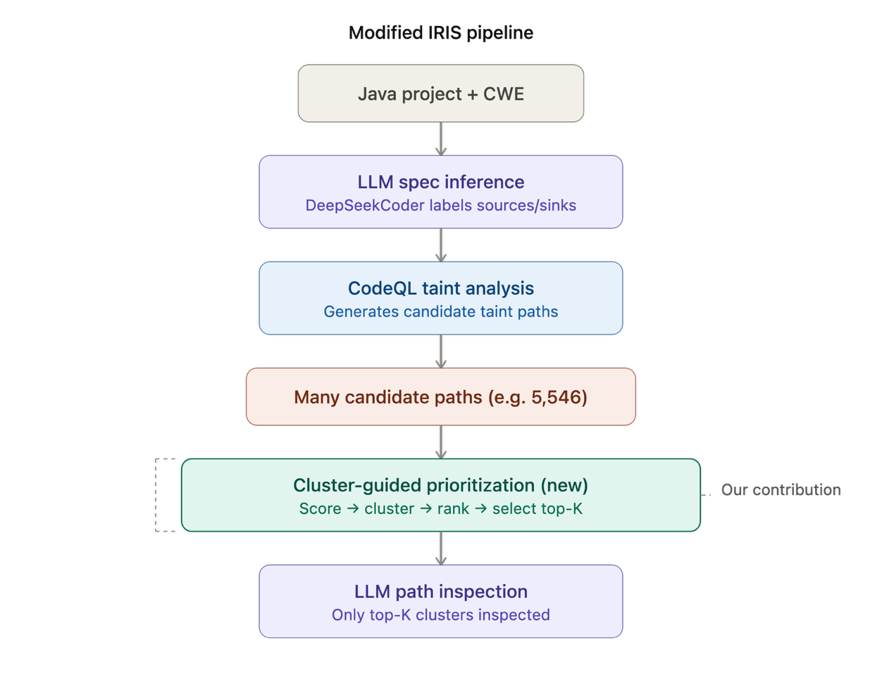
Figure 1: Modified IRIS pipeline with cluster-guided prioritization layer inserted between path generation and LLM inspection.
5. Cluster-Guided Path Prioritization
We propose a cluster-guided path prioritization layer that is inserted between CodeQL path generation and LLM inspection. The layer scores individual paths using CWE-specific heuristics, groups similar paths into clusters, ranks clusters using a composite score with convergence signals, and forwards only the top-K clusters for expensive LLM analysis. It adds under one second of computation and requires no additional LLM calls or GPU resources. Importantly, the layer does not replace any component of IRIS — it acts as a filter that selects which paths deserve expensive downstream analysis. Figure 1 illustrates where this layer fits within the modified IRIS pipeline.
5.1 Path Feature Extraction
From each SARIF-format taint path, we extract lightweight structural features: source URI and file name (where tainted data originates), sink URI and file name (where tainted data reaches a potentially dangerous operation), path length (number of intermediate code locations between source and sink), number of distinct files traversed by the path, and the CWE type under analysis. These features require only parsing the SARIF JSON output — no additional CodeQL queries or LLM calls.
5.2 CWE-Aware Scoring
Each path p receives a numeric risk score based on six feature categories:
Score(p) = f_sink(p) + f_source(p) + f_bsrc(p) + f_bsnk(p) + f_len(p) + f_cross(p)
Table 6 defines the six features used to compute the risk score for each path. Positive weights indicate features associated with real vulnerabilities; negative weights penalize patterns strongly associated with false positives. The weight magnitudes were calibrated so that no single feature dominates — a path needs multiple positive signals to rank highly.
Table 6: Scoring Features
Feature | Value | Condition
f_sink | +3 | Sink file matches CWE-specific dangerous patterns
f_source | +3 | Source file matches CWE-specific input patterns
f_bsrc | −3 | Source matches benign patterns (Exception, Logger, Config, Test, ...)
f_bsnk | −3 | Sink matches benign patterns (toString, Logger, Encoder, Proxy, ...)
f_len | +2 / +1 / −1 | Path length ≤ 8 / ≤ 15 / > 50 steps
f_cross | +1 | Path traverses ≥ 2 distinct files
The weight magnitudes and signs reflect the relative importance of each feature for vulnerability assessment, grounded in how taint analysis vulnerabilities manifest in practice.
Sink identity receives the highest positive weight (+3) because in taint analysis, the sink determines the impact of a vulnerability. A tainted data flow is only dangerous if it terminates at an operation capable of causing harm — evaluating an expression, writing to an HTTP response, or accessing the filesystem with an attacker-controlled path. This mirrors how CodeQL itself organizes security queries: each CWE-specific query targets a defined set of dangerous sinks. Our scoring extends this principle to LLM-inferred sinks that CodeQL does not natively recognize. The patterns are CWE-specific because a method like eval() is dangerous for code injection (CWE-94) but irrelevant for path traversal (CWE-22). A generic pattern list across CWE types would introduce false rankings.
Source identity receives equal weight (+3) because a taint path is only exploitable if the attacker can control the input. A path originating from request.getParameter() represents attacker-controllable data, while a path from Config.getDefault() represents internal program state that an attacker cannot influence. Even if both paths reach the same dangerous sink, only the first is exploitable. Source controllability is a binary security property — either the attacker controls the input or they do not — making it as decisive as sink dangerousness.
The benign source and sink penalties (−3 each) address a specific failure mode of LLM-based specification inference: over-labeling. In our Struts reproduction data, 1,322 of 5,546 paths (23.8%) originated from XWorkException.java — an exception class the LLM labeled as a taint source despite being generated internally by the program. Similarly, the top three false positive sinks — FelixOsgiHost.java (138 paths), PackageBasedActionConfigBuilder.java (130 paths), and ResourceFinder.java (122 paths) — are infrastructure code that loads configurations or discovers resources. These 390 paths (7.2% of all Struts paths) are definitively not exploitable. The symmetric weight (−3 versus +3) ensures that a path exhibiting both a benign and a dangerous pattern receives a net-zero contribution from those features, requiring other features to determine its ranking.
Path length scoring (+2/+1/−1) reflects the observation that shorter taint flows more directly represent exploitable vulnerability paths. A 4-step path from request.getParameter() to Runtime.exec() is a clear injection vector. A 60-step path through multiple utility classes, factories, and wrappers is more likely to involve intermediate sanitization or type conversion that breaks the taint chain in practice, even when the static analysis cannot prove it. This is consistent with findings in path-sensitive verification literature (Ball and Rajamani, 2002): shorter paths through the program state space are generally more feasible and more likely to correspond to real executions. In our Spring Cloud Gateway data, true positive paths averaged 6 steps while false positive paths averaged 14 steps, empirically supporting this heuristic.
The cross-file flow bonus (+1) is deliberately small because it is a soft signal rather than a decisive indicator. Inter-module taint flows — from a controller to a service to a utility — are harder to detect through manual code review and more likely to represent genuine security-relevant data movement. The low weight ensures it acts as a tiebreaker rather than overriding content-based features.
Table 7: CWE-Specific Dangerous Patterns
CWE | Dangerous Sink Patterns | Dangerous Source Patterns
CWE-94 | ognl, eval, exec, invoke, execute, expression, interceptor, parameter, valuestack, spel, script | request, param, servlet, http, controller, action, gateway
CWE-79 | request, response, http, wrapper, validator, html, render, output, utilities | request, param, servlet, http, validator, cookie
CWE-22 | file, path, stream, zip, extract, archive, entry, directory, resource | request, param, upload, multipart, servlet, http
These patterns were derived empirically by analyzing TP versus FP paths in our reproduction data. For example, in Struts the TP sinks were concentrated in ParametersInterceptor.java (41 paths), HttpParameters.java (29), and OgnlValueStack.java (8), while the FP sinks were dominated by infrastructure code: FelixOsgiHost.java (138), PackageBasedActionConfigBuilder.java (130), and ResourceFinder.java (122). Similarly, 1,322 of the 5,546 Struts paths originated from XWorkException.java — an exception class that is clearly not attacker-controllable, making the benign source penalty particularly effective. In practice, path scores range from roughly −6 to +9. Figure 2 visualizes this separation between TP and FP sink files in Struts.
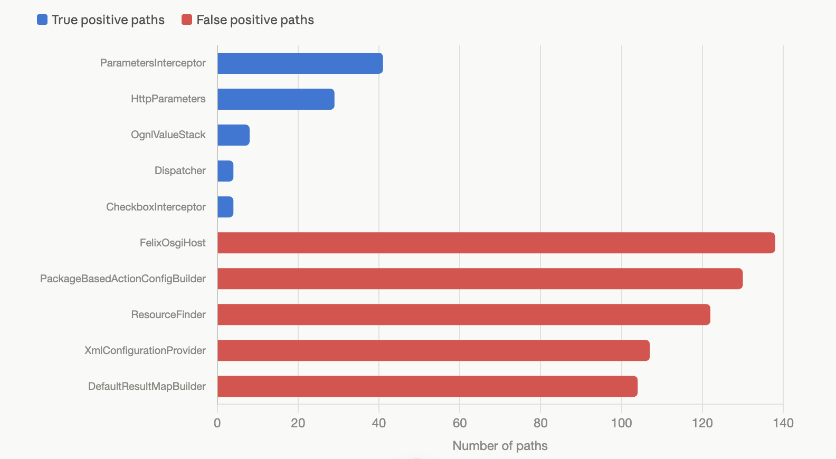
Figure 2: Distribution of true positive versus false positive paths by sink file in Struts, showing clear lexical separation between vulnerable sinks (ParametersInterceptor, HttpParameters) and benign sinks (FelixOsgiHost, PackageBasedActionConfigBuilder).
5.3 Path Clustering
A key observation from our data is that many IRIS-generated paths are near-duplicates. In Struts, hundreds of paths share the same source and sink files but differ only in one or two intermediate steps. Ranking 5,546 individual paths treats each near-duplicate independently, wasting both computational resources and analyst attention.
We group paths into clusters using a signature:
σ(p) = ⟨ FileName(source(p)), FileName(sink(p)), LenBucket(|p|), CWE ⟩
We use signature-based clustering rather than embedding-based similarity or hierarchical clustering for three reasons. First, it is deterministic and interpretable — each cluster can be described by its signature components, making results explainable to developers and auditors. Second, it is computationally trivial: a single O(n) pass with a hash map, adding no meaningful overhead to the pipeline. Third, it directly targets the primary axis of redundancy we observed in IRIS output: near-duplicate paths overwhelmingly share the same source file, sink file, and approximate length, differing only in intermediate steps. More sophisticated similarity measures would provide marginal improvement at significant complexity cost. The length bucketing prevents paths of the same source-sink pair but very different lengths from being grouped together, since path length affects both feasibility and risk profile as discussed above.
Table 8 shows the effect of signature-based clustering on path volume. The reduction percentage indicates how many paths were redundant — sharing the same source file, sink file, and length category as at least one other path. For Struts, 5,546 paths collapse into 1,647 clusters, meaning each cluster contains 3.4 near-duplicate paths on average.
Table 8: Clustering Reduction
Project | Raw Paths | Clusters | Reduction
Struts | 5,546 | 1,647 | 70%
ff4j | 1,083 | 341 | 69%
Rocketmq | 1,272 | 453 | 64%
ESAPI | 610 | 223 | 63%
Antisamy | 129 | 26 | 80%
Commons-text | 201 | 63 | 69%
Average | — | — | 63%
5.4 Cluster Ranking with Convergence Signals
Each cluster receives a composite score equal to the maximum individual path score among its members, plus a convergence bonus based on cluster size:
ClusterScore(C) = max_{p ∈ C} Score(p) + Convergence(C)
where:
Convergence(C) = { +1 if |C| ≥ 5; +2 if |C| ≥ 20; 0 otherwise }
The convergence bonus is grounded in the observation that systematic vulnerability patterns are more significant than isolated occurrences. When many distinct taint flows converge to the same source-sink pattern, this indicates a design-level vulnerability — the same dangerous API is reachable from multiple entry points — rather than an incidental single-path anomaly. This reasoning parallels observations in path-sensitive model checking (Ball and Rajamani, 2002), where repeated traversal of similar state-space regions indicates systematic program behavior rather than edge cases.
The bonus thresholds (≥5 and ≥20 paths) were chosen based on cluster size distributions in our data. Across all projects, the median cluster size is 2–3 paths. Clusters with 5 or more paths fall in the upper quartile, and clusters with 20 or more are statistical outliers representing dominant code patterns. The bonus values (+1 and +2) are deliberately small relative to the path-level features (±3) so that convergence acts as a tiebreaker among similarly-scored clusters rather than overriding content-based scoring. In the Struts data, this design proved critical: the cluster "HttpParameters → ParametersInterceptor (long)" contains 30 paths, all true positives. Without the convergence bonus it would score +9, identical to several false positive clusters. With the bonus it scores +11, rising to its correct position near the top of the ranking.
5.5 Top-K Cluster Selection
Only the top-K ranked clusters are forwarded for LLM inspection. The parameter K is configurable, allowing practitioners to trade off between coverage and cost. At K = 20, the method saves an average of 68% of LLM calls across all projects. For Struts, only 106 paths (from the top 20 clusters) are sent instead of 5,546 — a 98% reduction — while retaining 47.5% of true positive paths with the most critical vulnerability-containing cluster appearing first.
This selection also addresses a practical issue we observed with DeepSeekCoder 7B: the model frequently fails to produce valid JSON during the contextual path filtering stage (Stage 8 of IRIS). By sending only the highest-priority paths, we reduce wasted LLM calls on low-quality paths and increase the proportion of paths for which the analysis succeeds. Figure 3 shows the five internal steps of the prioritization method.
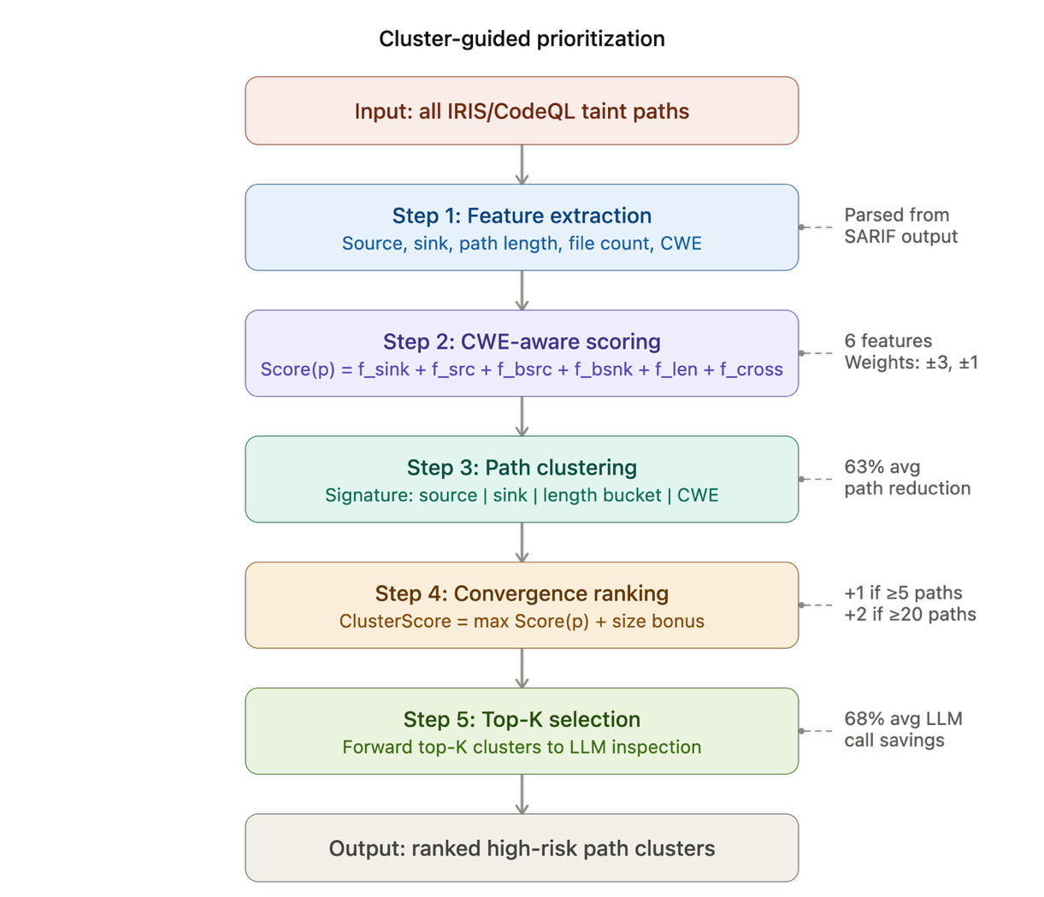
Figure 3: Internal steps of the cluster-guided prioritization method.

6. Fine-Tuned API Labeling
Path prioritization addresses noise after paths are generated. Fine-tuning addresses noise before paths are generated — at the specification inference stage (Stage 3) where the LLM labels APIs as sources, sinks, or neither. The two optimizations target different pipeline stages and are complementary.
6.1 Motivation and Data Collection
During reproduction, we observed that DeepSeekCoder 7B's specification inference was noisy: it sometimes labeled irrelevant APIs as sources or sinks (e.g., java.lang.String.length() as a source, java.util.Map.values() as a sink). These incorrect labels cause CodeQL to generate taint paths with no security relevance, directly contributing to path explosion.
Table 9 shows the composition of the fine-tuning dataset. Sources include APIs like javax.servlet.http.HttpServletRequest.getParameter() and java.io.BufferedReader.readLine() — methods that accept external input. Sinks include APIs like java.lang.Runtime.exec() and javax.script.ScriptEngine.eval() — methods that perform security-sensitive operations. The "none" category includes APIs like java.lang.String.length() and java.util.HashMap.get() that the LLM correctly identified as neither sources nor sinks.
Table 9: Fine-Tuning Dataset
Label | Count | Percentage
Source | 1,145 | 36.1%
Sink | 1,373 | 43.3%
None (sampled) | 652 | 20.6%
Total | 3,170 | 100%
Split: 2,536 train / 317 validation / 317 test. Each example is formatted as an instruction prompt matching IRIS's query format: "Classify the following Java API as 'source', 'sink', or 'none' for [CWE]. Package: ... Class: ... Method: ... Signature: ... Classification: [label]"
6.2 Fine-Tuning Configuration
We used LoRA (Low-Rank Adaptation) to fine-tune DeepSeekCoder 7B, training only small rank-decomposition matrices inserted into the attention layers while keeping the original weights frozen. This allows fine-tuning a 7B-parameter model on a single A100 GPU in minutes.
Table 10: LoRA Configuration
Parameter | Value
Rank (r) | 8
Alpha | 16
Dropout | 0.05
Target modules | q_proj, v_proj
Trainable parameters | 4,194,304 / 6.7B total (0.06%)
Epochs | 3
Effective batch size | 16 (4 × 4 gradient accumulation)
Learning rate | 2 × 10⁻⁴
Training time | ~15 minutes on a single NVIDIA A100 GPU
The training loss remained relatively flat (~29.2–29.4), which is characteristic of causal LM fine-tuning where loss is computed over the full prompt including input context. Despite this, evaluation shows clear improvement.
6.3 Results
Table 11 compares the base and fine-tuned model on 100 held-out API classification examples. The "Output Behavior" column highlights a qualitative difference beyond raw accuracy: the base model frequently produced unparseable verbose text, while the fine-tuned model consistently produced single-word labels usable by the IRIS pipeline.
Table 11: API Classification Accuracy
Model | Accuracy | Output Behavior
Base DeepSeekCoder 7B | 53% | Often verbose, malformed ("classify the followi...")
Fine-tuned (LoRA) | 82% | Concise, clean labels (source/sink/none)
Improvement | +29 points | Format failures eliminated entirely
The base model's errors were a mix of format failures (producing verbose text instead of labels) and semantic misclassifications. The fine-tuned model eliminated format failures entirely — its remaining errors were semantic (e.g., labeling a source as a sink), indicating it learned the output format reliably but occasionally struggled with the distinction between source and sink roles.
End-to-end pipeline evaluation (whether better API labeling translates to fewer false positive paths and improved vulnerability detection) is left as future work. The 29-point accuracy improvement suggests meaningful upstream noise reduction is achievable, and combining fine-tuned specification inference with cluster-guided path prioritization could optimize both input quality and output efficiency of the IRIS pipeline.

7. Experimental Setup
7.1 Dataset
We evaluate on CWE-Bench-Java, a benchmark of real-world Java vulnerabilities with ground truth from actual CVE patches. Our evaluation covers 16 projects: CWE-94 (Code Injection, 6 projects), CWE-79 (XSS, 5 projects), and CWE-22 (Path Traversal, 5 projects). Projects range from small libraries (~500 LOC) to large frameworks (Struts, ~10K files compiled). Nine additional benchmark projects failed to build on our environment due to dependency issues or complex multi-module configurations.
7.2 Path Labeling Methodology
A path is labeled as a true positive if any step passes through a source file listed in CWE-Bench-Java's fix_info.csv — the exact files modified in the CVE patch. This matches the original IRIS paper's labeling methodology (Recall@File). It is an approximation: a path may touch a fix file for unrelated reasons (false positive label), or a genuine vulnerability path may not touch the fix file (false negative label). We discuss the implications in Threats to Validity.
7.3 Baselines
We evaluate five configurations to isolate each component's contribution:
Configuration | Description
Original IRIS | All paths sent to LLM, no prioritization
Scoring only | Individual paths ranked by heuristic score, no clustering
Clustering only | Paths grouped by signature, clusters ranked by size, no scoring
Scoring + Clustering | Clusters ranked by max path score, no convergence bonus
Full method | Scoring + Clustering + convergence bonus (proposed approach)
7.4 Metrics
Metric | What It Measures | Why It Matters
Precision@K | TP fraction in top-K cluster paths | Practical usability — fewer false positives for reviewers
Recall@K | Fraction of all TPs retained in top-K | Safety — are real vulnerabilities kept? (primary metric)
NDCG@K | Ranking quality with positional discount | Research-standard ranking evaluation
MRR | Position of first TP cluster | Developer efficiency — how quickly is first vulnerability found?
Path Reduction | % paths eliminated by clustering | Raw redundancy removal
LLM-call Savings | % LLM calls saved by top-K selection | Direct cost reduction

8. Results
We organize results around six research questions addressing the core claims of this work.
8.1 RQ1: Can IRIS be reproduced with an open-source LLM?
Yes. After five compatibility fixes, IRIS with DeepSeekCoder 7B detected 9/16 vulnerabilities — all where CodeQL found zero or very few alerts.
Table 12: Detection Summary
CWE Type | Projects | IRIS Detected | CodeQL Baseline
CWE-94 (Code Injection) | 6 | 6/6 (100%) | 0 alerts on all
CWE-79 (XSS) | 5 | 2/5 (40%) | 0–3 alerts
CWE-22 (Path Traversal) | 5 | 1/5 (20%) | 0–12 alerts
Total | 16 | 9/16 (56%) | —
The reproduction confirms IRIS's core value — LLM-inferred specifications extend CodeQL's reach — while quantifying the path explosion problem: the 9 detected projects generated 10,274 total paths with only 666 true positives (6.5% overall precision). Figure 4 visualizes this complementary relationship between CodeQL and IRIS across CWE types.
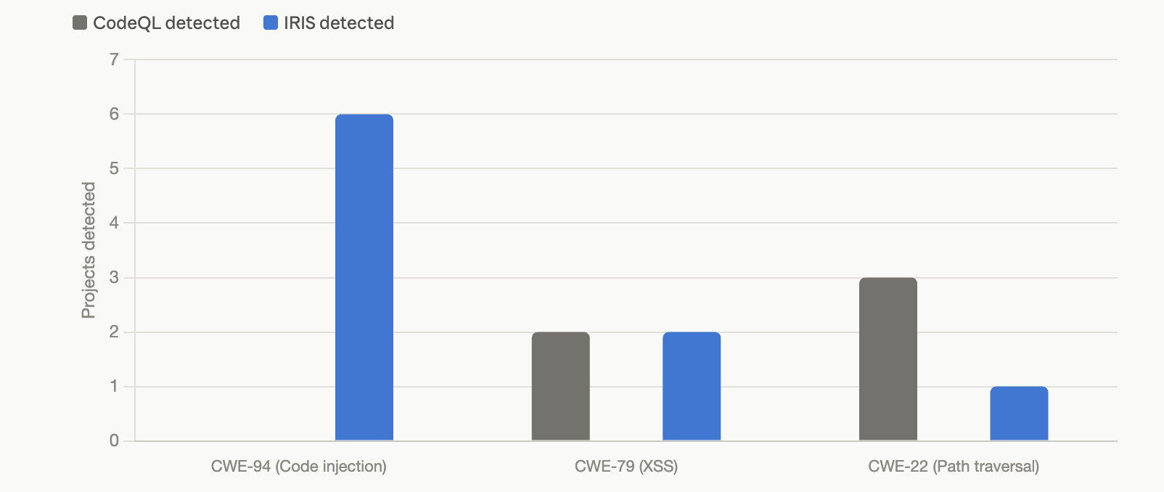
Figure 4: Comparison of vulnerability detection rates between CodeQL and IRIS across three CWE types, highlighting IRIS's strength on CWE-94 where CodeQL finds zero alerts.
8.2 RQ2: Does prioritization reduce LLM inspection cost?
Yes. Clustering reduces distinct path groups by 63% on average. With top-20 selection, the full method saves 68% of LLM calls on average.
Table 13: Original IRIS vs Cluster-Guided Prioritization
Project | Paths | Clusters | Top-20 Paths | LLM Saved | R@20 | MRR
Struts | 5,546 | 1,647 | 106 | 98% | 47.5% | 1.000
ff4j | 1,083 | 341 | 31 | 97% | 3.7% | 0.500
Rocketmq | 1,272 | 453 | 65 | 95% | 0.0% | 0.006
ESAPI | 610 | 223 | 56 | 91% | 8.2% | 0.200
Spring-cloud-gw | 310 | 99 | 49 | 84% | 37.0% | 0.059
Commons-text | 201 | 63 | 41 | 80% | 12.5% | 0.250
Antisamy | 129 | 26 | 98 | 24% | 57.1% | 0.333
Plexus-archiver | 59 | 34 | 35 | 41% | 100% | 0.056
Cron-utils | 18 | 11 | all | 0% | 100% | 0.250
The headline result is Struts: the original pipeline sends 5,546 paths to the LLM; our method sends 106 — a 98% reduction. A developer examines 106 paths instead of 5,546, and the first cluster examined contains a real vulnerability (MRR = 1.000). The smallest reductions occur on projects with few total paths (Cron-utils, Antisamy) where clustering provides less compression. Figure 5 shows the LLM-call savings per project.
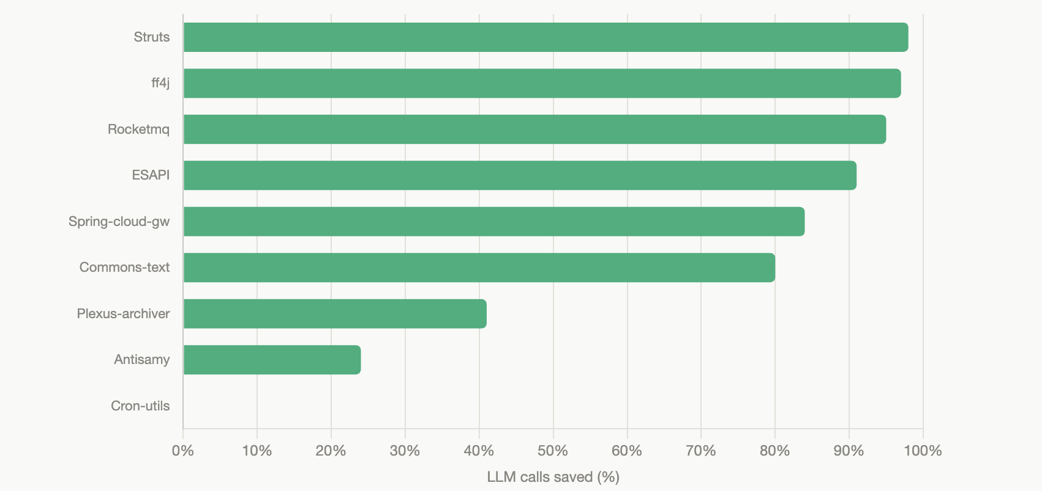
Figure 5: Percentage of LLM inspection calls saved per project through top-K cluster selection, with larger projects like Struts achieving up to 98% reduction.
8.3 RQ3: Are true positives preserved near the top?
For most projects, yes.
Table 14: Ranking Quality (Full Method, Cluster-Level)
Project | P@10 | R@10 | NDCG@10 | MRR
Struts | 51.8% | 43.6% | 0.478 | 1.000
Cron-utils | 43.8% | 77.8% | 0.416 | 0.250
ESAPI | 47.4% | 8.2% | 0.221 | 0.200
ff4j | 23.5% | 2.5% | 0.401 | 0.500
Antisamy | 16.4% | 47.6% | 0.395 | 0.333
Commons-text | 32.0% | 6.7% | 0.164 | 0.250
Spring-cloud-gw | 0.0% | 0.0% | 0.000 | 0.059
Plexus-archiver | 0.0% | 0.0% | 0.000 | 0.056
Rocketmq | 0.0% | 0.0% | 0.000 | 0.006
Struts P@10 = 51.8% versus baseline 1.8% — a 28.8× precision improvement. Nearly half the true vulnerabilities appear in just the first 10 clusters. Cron-utils achieves R@20 = 100%: every true positive is captured within the top 20 clusters. The weakest results are Rocketmq (single TP hidden in 1,272 paths) and Spring Cloud Gateway (TPs don't match typical CWE-94 naming patterns) — analyzed in RQ5. Figure 6 illustrates this precision-recall tradeoff for Struts as K increases.
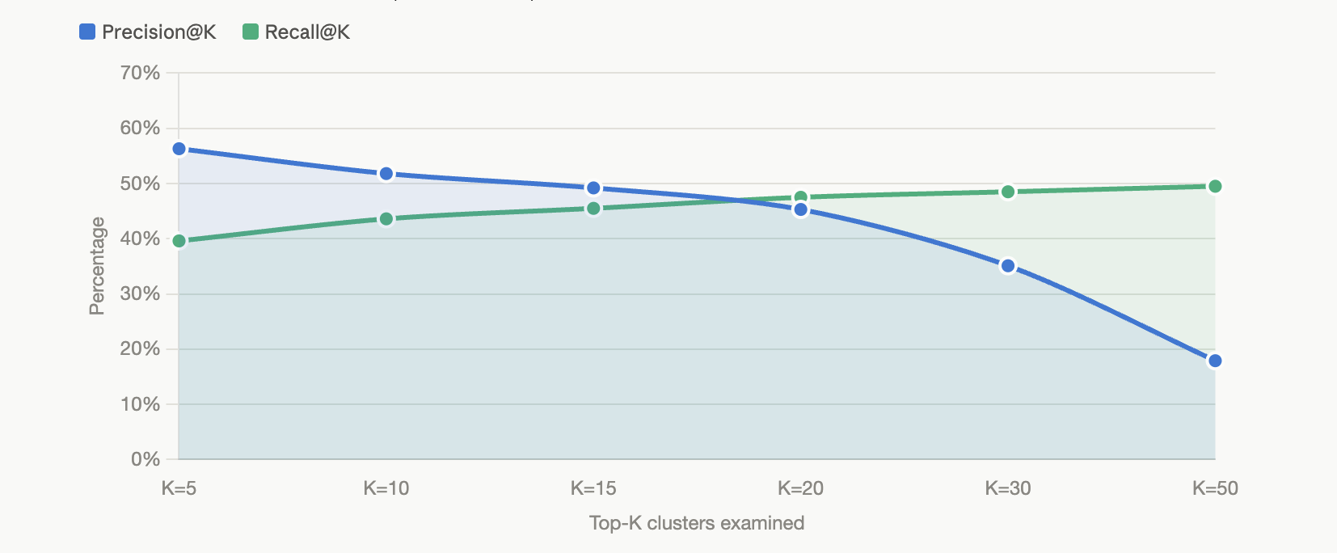
Figure 6: Precision and recall tradeoff as the number of examined clusters (K) increases for Struts, showing that precision decreases while recall plateaus around 50%.
8.4 RQ4: Ablation Study
Table 15: Ablation — Struts (5,546 paths, 101 TPs)
Variant | P@10 | R@10 | NDCG@10 | MRR | Primary Strength
Scoring only | 60.0% | 5.9% | 0.727 | 1.000 | Precision
Clustering only | 7.6% | 29.7% | 0.073 | 0.143 | Recall
Scoring + Clustering | 46.7% | 13.9% | 0.469 | 1.000 | Mixed
Full (+ convergence) | 51.8% | 43.6% | 0.478 | 1.000 | Balance
Figure 7 visualizes this precision-recall balance across the four ablation variants.
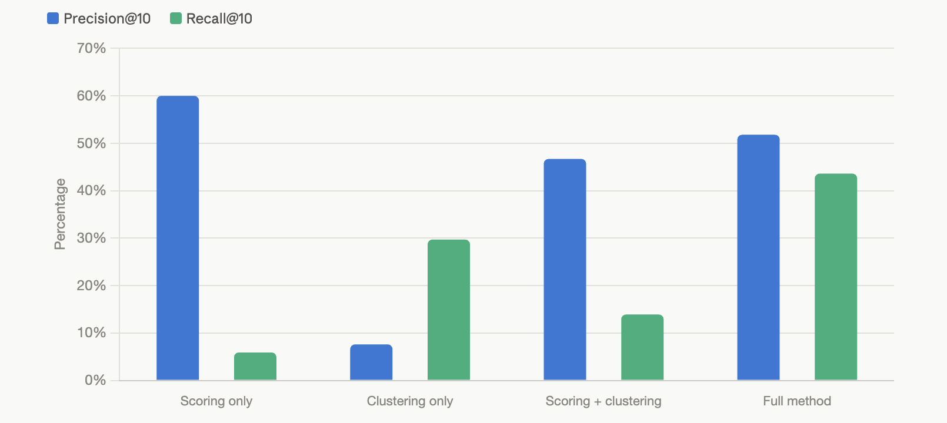
Figure 7: Ablation study on Struts comparing precision and recall across four method variants, demonstrating that the full method achieves the best balance between the two metrics.
Table 16: Ablation — Commons-text (201 paths, 120 TPs)
Variant | P@10 | R@10 | NDCG@10 | MRR | Primary Strength
Scoring only | 20.0% | 1.7% | 0.143 | 0.143 | —
Clustering only | 59.3% | 45.0% | 0.652 | 1.000 | Both
Scoring + Clustering | 14.3% | 1.7% | 0.095 | 0.250 | —
Full (+ convergence) | 32.0% | 6.7% | 0.164 | 0.250 | Mixed
Table 17: Ablation — ESAPI (610 paths, 220 TPs)
Variant | P@10 | R@10 | NDCG@10 | MRR | Primary Strength
Scoring only | 0.0% | 0.0% | 0.000 | 0.031 | —
Clustering only | 33.9% | 18.2% | 0.393 | 1.000 | Both
Scoring + Clustering | 0.0% | 0.0% | 0.000 | 0.053 | —
Full (+ convergence) | 47.4% | 8.2% | 0.221 | 0.200 | Precision
The ablation reveals that no single component dominates across all projects, validating the multi-component design. Scoring alone excels at precision when vulnerability patterns are lexically distinctive (Struts: 60% P@10). Clustering alone excels at recall when TPs naturally group together (Commons-text: 45% R@10, NDCG = 0.652). The full method provides the best overall balance — on Struts it achieves both 51.8% precision AND 43.6% recall, a combination that neither scoring nor clustering achieves independently. The convergence bonus is specifically responsible for lifting Struts recall from 13.9% (scoring + clustering) to 43.6% (full method), demonstrating that recognizing large clusters of similar flows as systematic vulnerability signals is a meaningful contribution beyond simple scoring.
8.5 RQ5: Per-CWE Analysis and Failure Cases
CWE-94 (Code Injection) — Strongest results. Dangerous sinks for code injection (OGNL evaluation, expression interpretation, script execution) have lexically distinctive names that rarely appear in benign code. This makes heuristic scoring highly effective. Struts achieves MRR = 1.000. The method works consistently across CWE-94 projects, with the exception of Rocketmq.
CWE-79 (XSS) — Mixed results. XSS involves HTTP request/response handling, which overlaps heavily with normal web application code. TP and FP paths share similar file names (e.g., DefaultHTTPUtilities appears in both). Clustering provides more benefit than scoring for CWE-79 because TPs tend to group around the same source-sink pairs even when individual path scores are similar to FPs.
CWE-22 (Path Traversal) — Weakest results. File I/O APIs (File, Path, InputStream) appear everywhere in Java applications — in logging, configuration, serialization, and normal resource management. The ubiquity of file operations makes lexical heuristics insufficient to distinguish dangerous from benign file access. Plexus-archiver is the exception because its vulnerability involves archive extraction (zip, extract), a distinctive enough pattern.
Failure cases. Rocketmq has only 1 TP among 1,272 paths (0.08% density). The fix file does not match common CWE-94 keywords. This represents the fundamental limit of unsupervised heuristic prioritization: when the vulnerable pattern is atypical and extremely rare, rule-based scoring cannot surface it. Spring Cloud Gateway's TPs flow through ShortcutConfigurable.java (SpEL evaluation). While "spel" is in our patterns, the file name itself does not match typical CWE-94 keywords, and many FPs also score highly due to HTTP-related naming in gateway filters. The method requires K ≥ 20 to capture any TPs.
8.6 RQ6: Does fine-tuning improve API labeling?
Yes. Base DeepSeekCoder achieved 53% accuracy on the test set; the fine-tuned model achieved 82% — a 29-point improvement. The base model frequently produced verbose, malformed output instead of clean labels. The fine-tuned model eliminated format failures entirely: its remaining errors were semantic misclassifications (confusing source and sink roles), not format problems. Training cost was minimal — ~15 minutes on a single NVIDIA A100 GPU, training only 0.06% of parameters via LoRA. End-to-end pipeline evaluation is left as future work, but the accuracy improvement suggests meaningful upstream noise reduction is achievable.

